Nama : Heru Ramdani

NIM : 1207070053

Kelas : PCD TKK

1. Flip Gambar

* Flip Horizontal

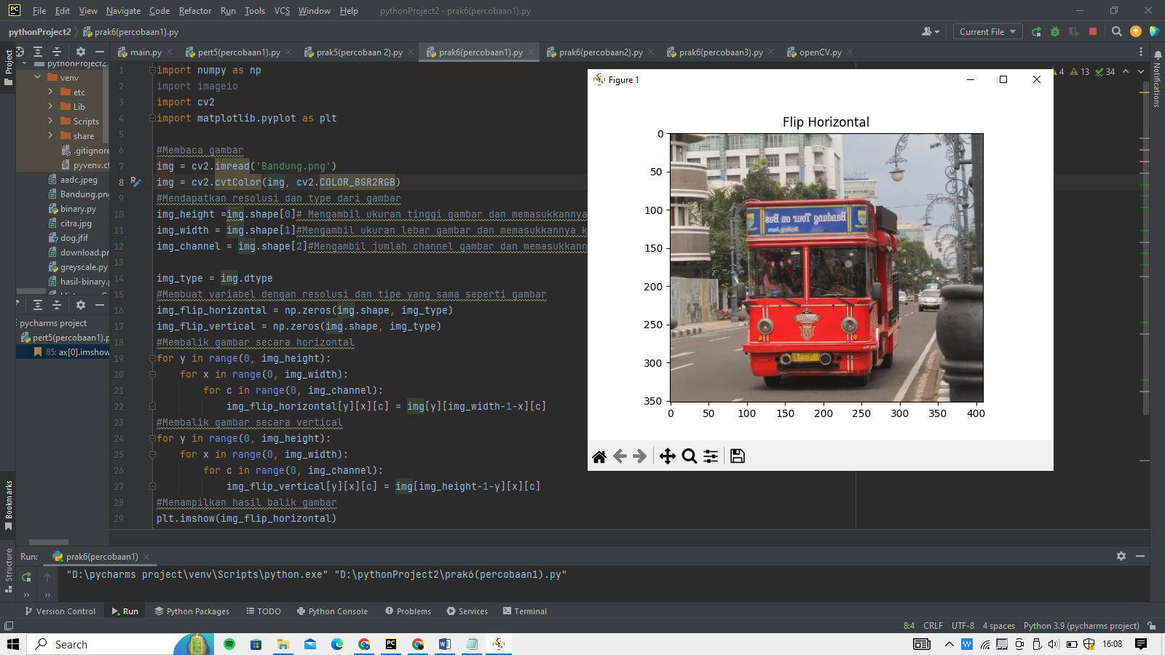

* Flip Vertical

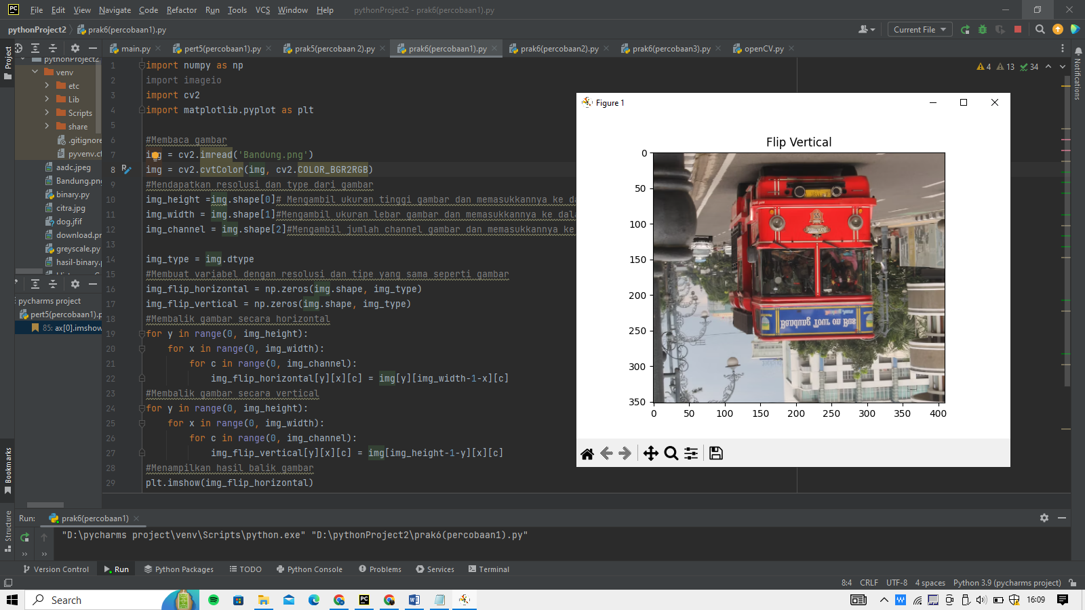

1. Histogram, Histogram Kumulatif, dan Histogram Hequalisasi

* Greyscale

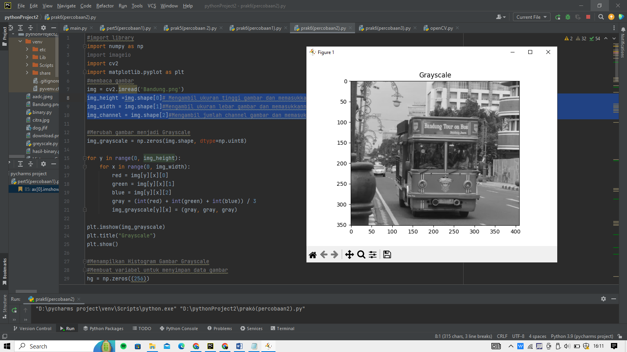

* Histogram Greyscale

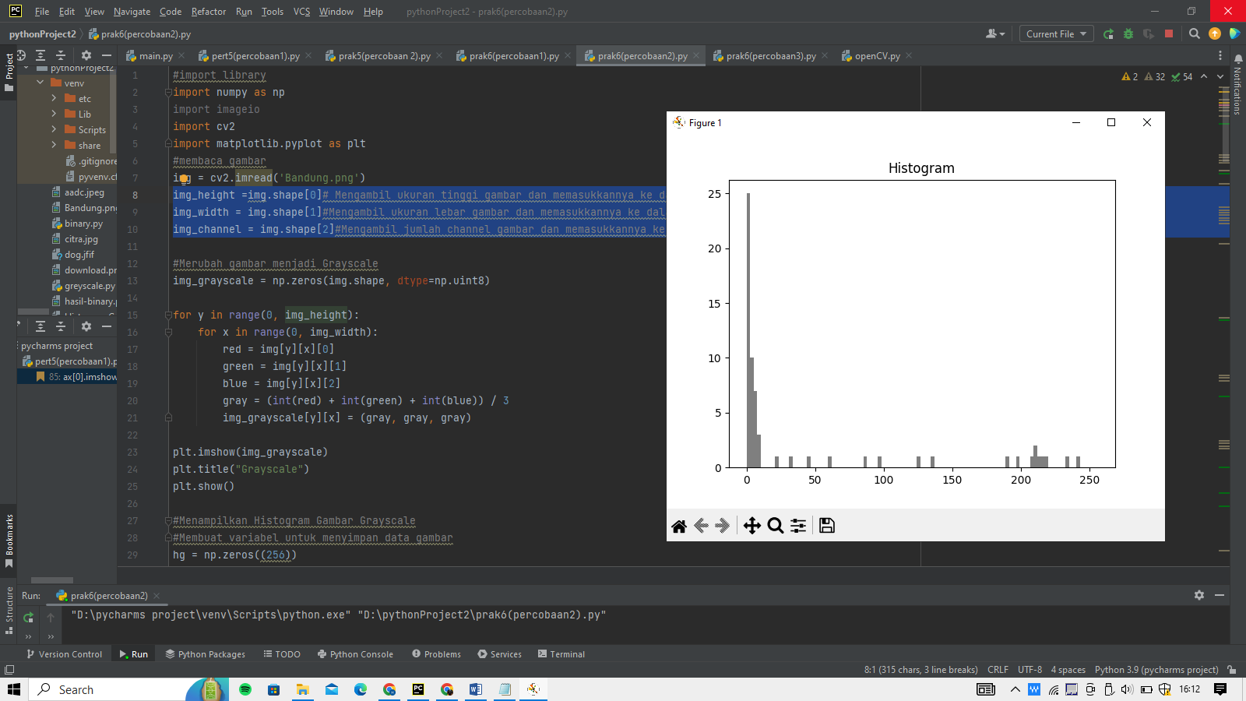

* Histogram Red Green Blue

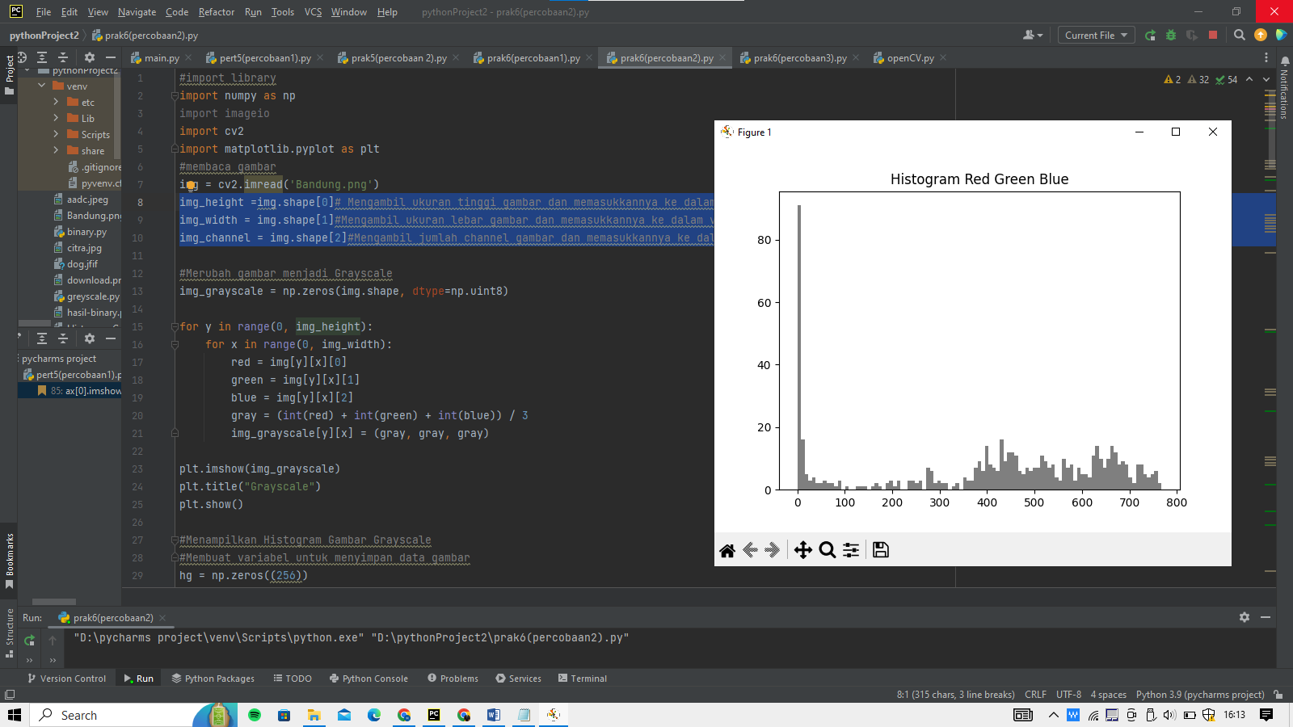

* Histogram Red

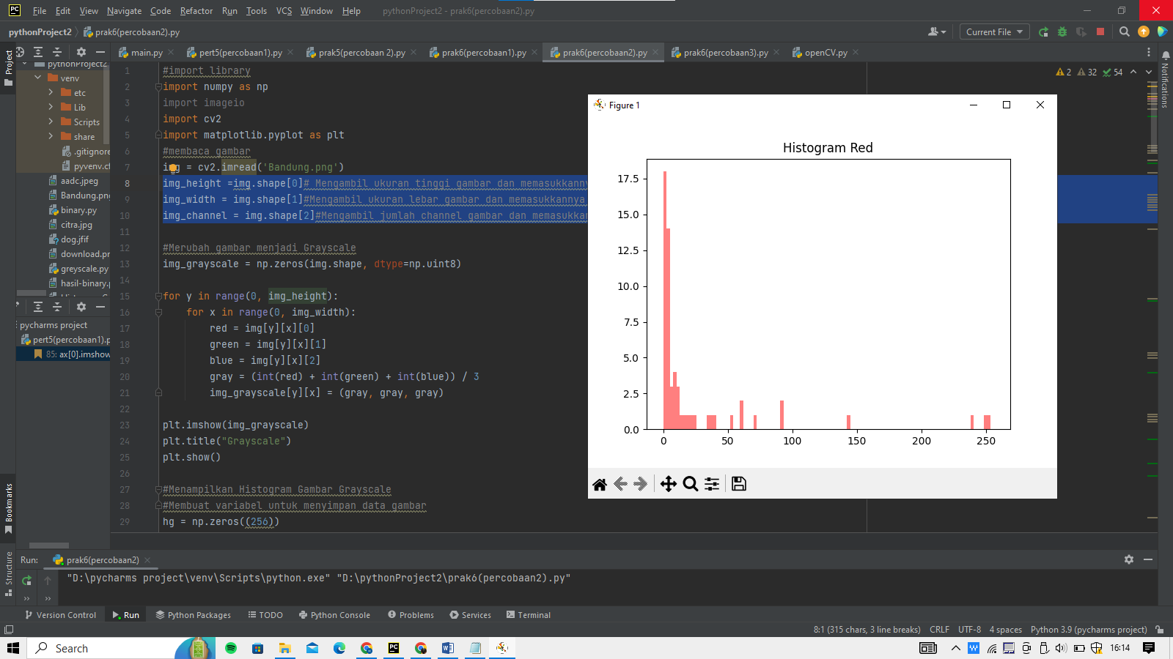

* Histogram Green

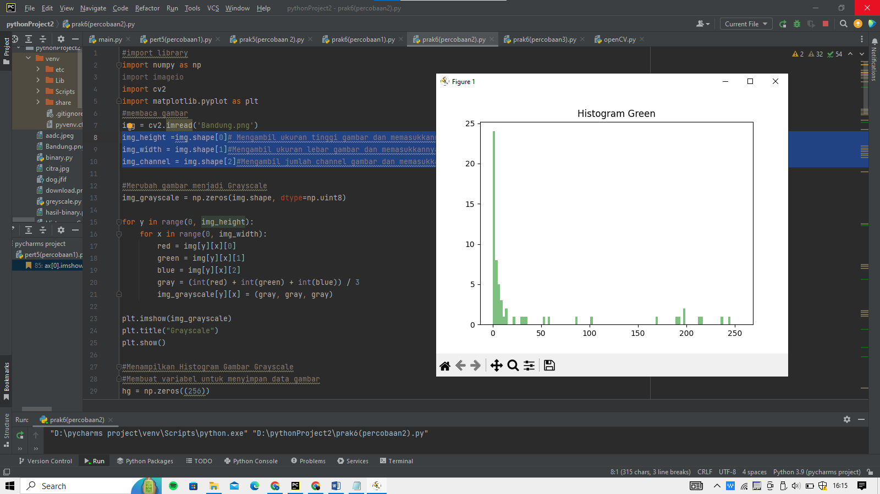

* Histogram Blue

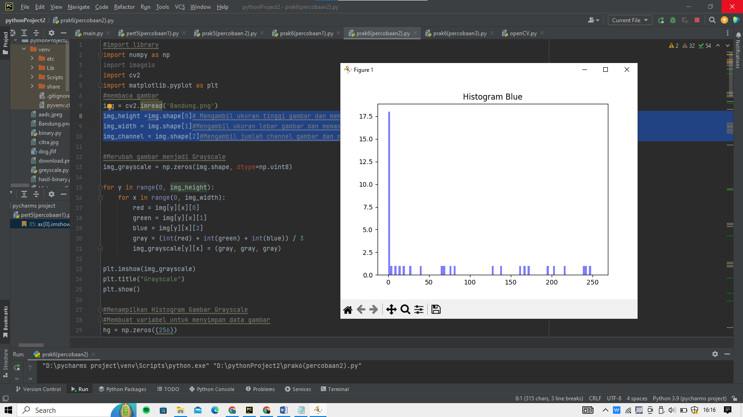

* Histogram greyscale Kumulatif

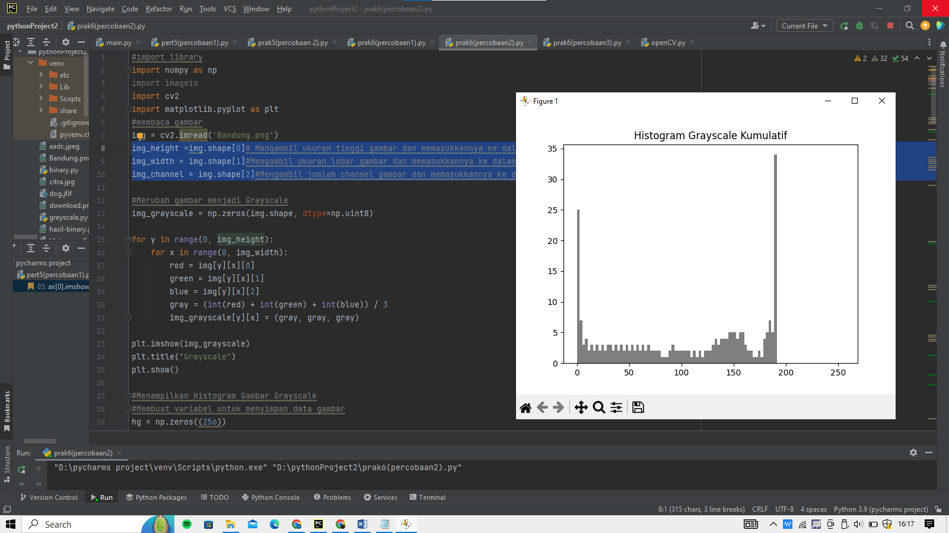

* Histogram greyscale hiqualisasi

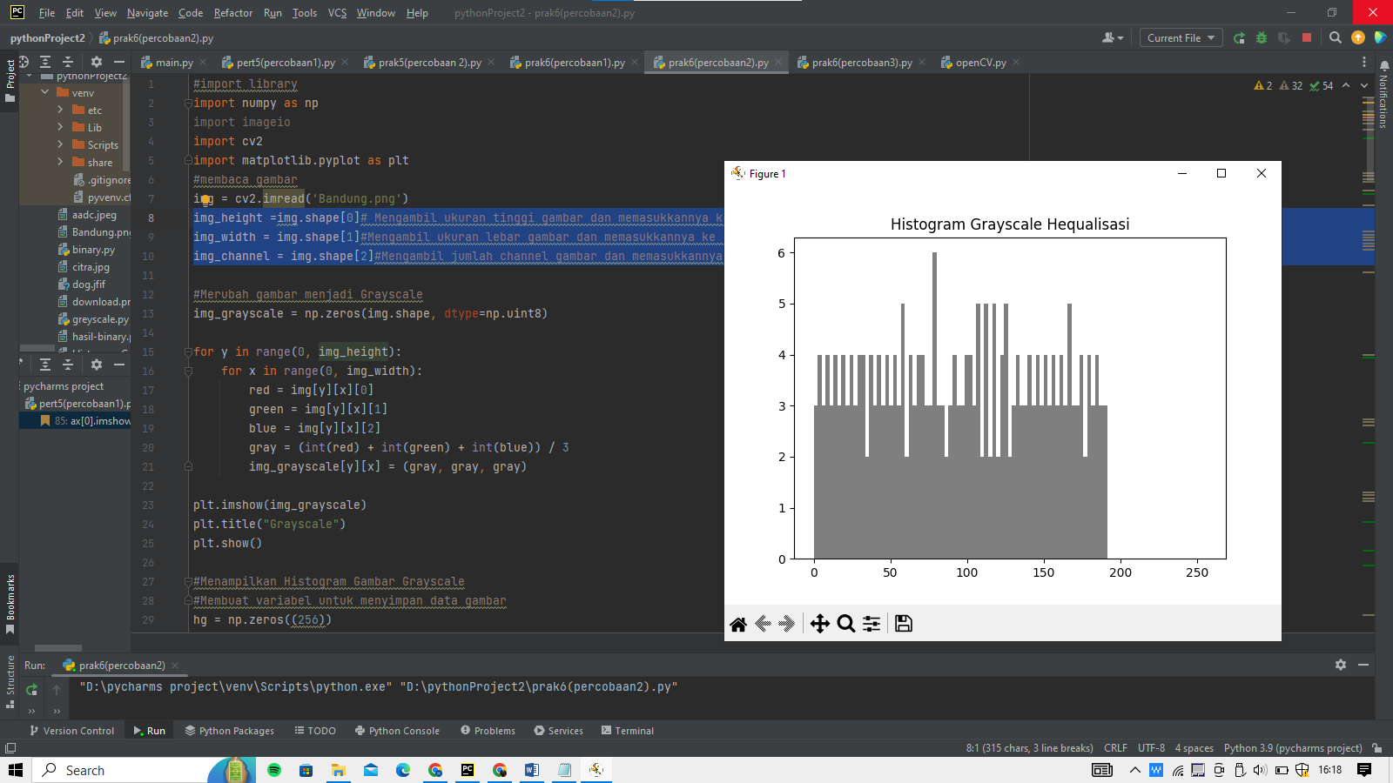

1. Inversi, Transformasi Logaritmik, Transformasi Powerlaw

* Inversi Greyscale

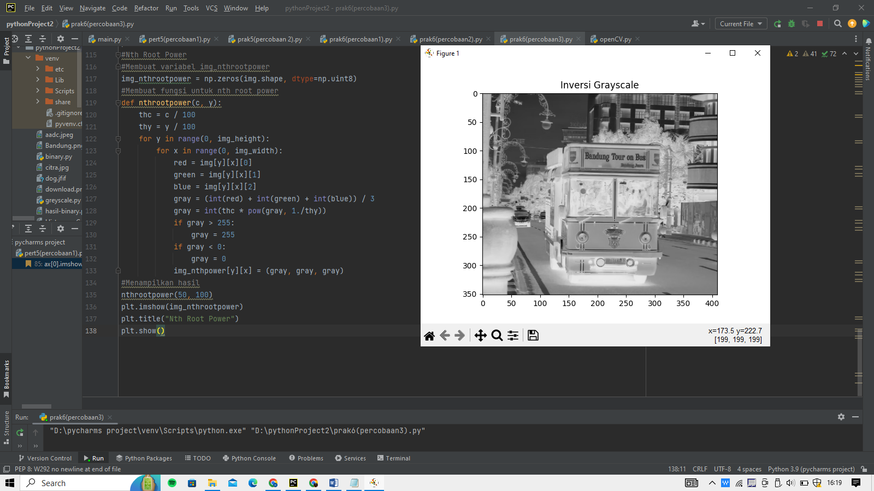

* Inversi RGB

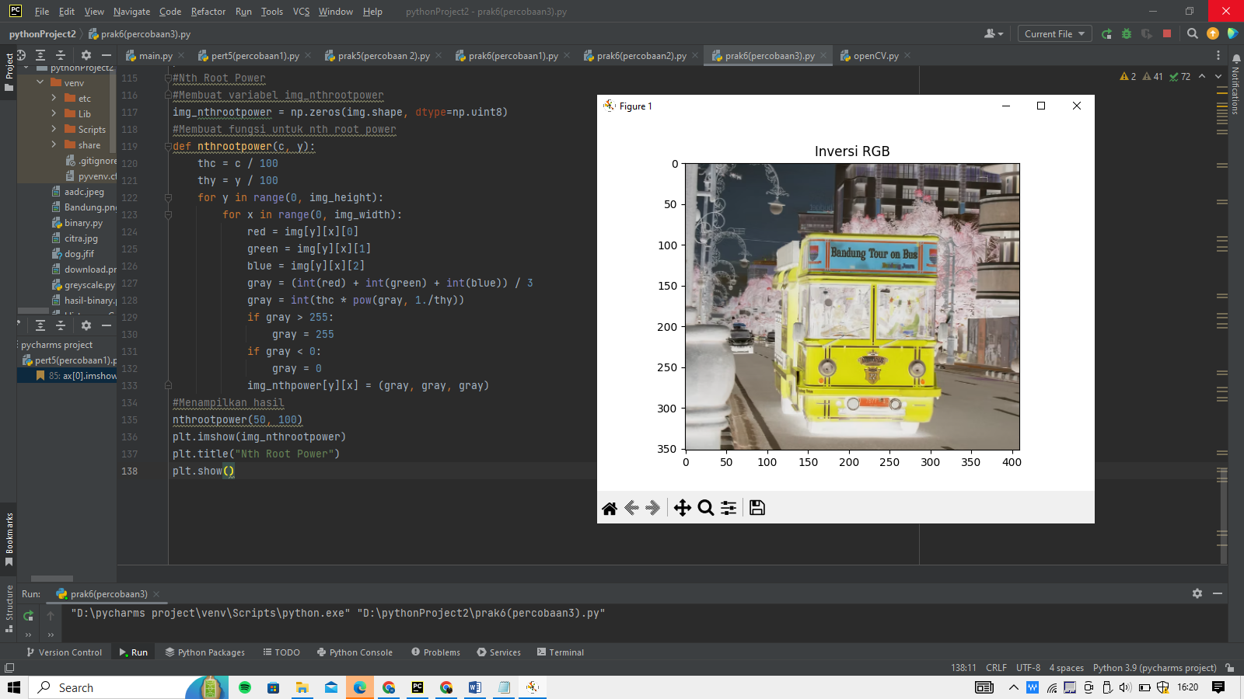

* Log

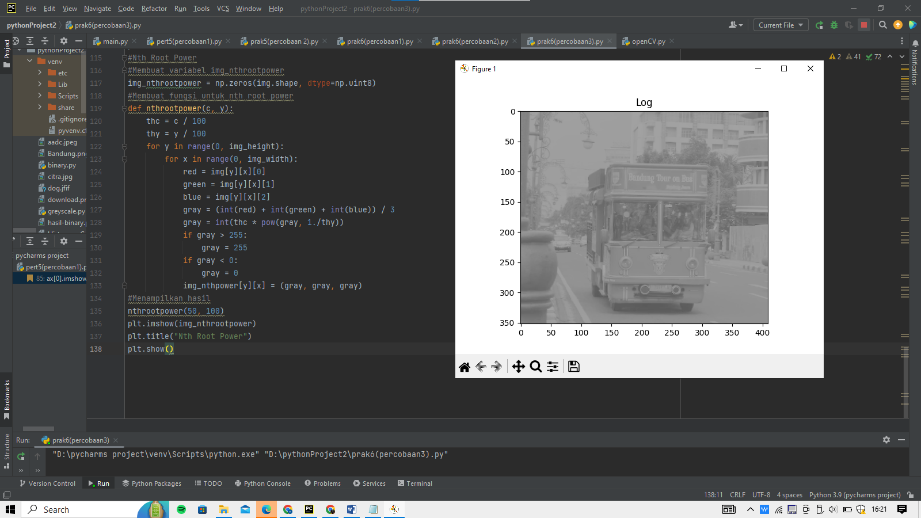

* Inversi & Log

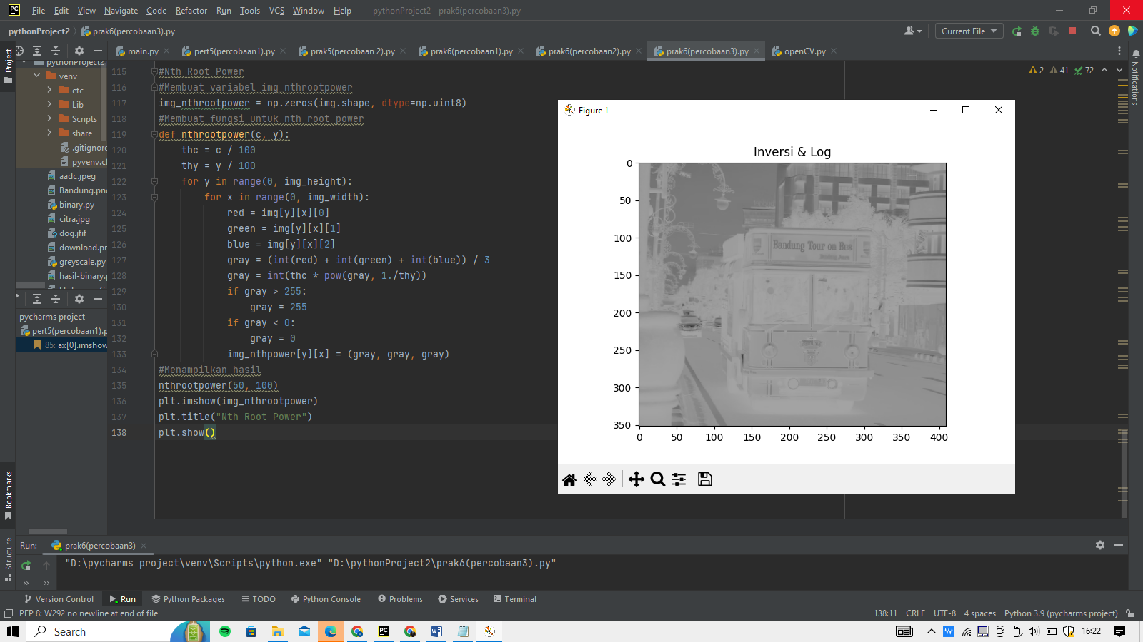

* NTH power

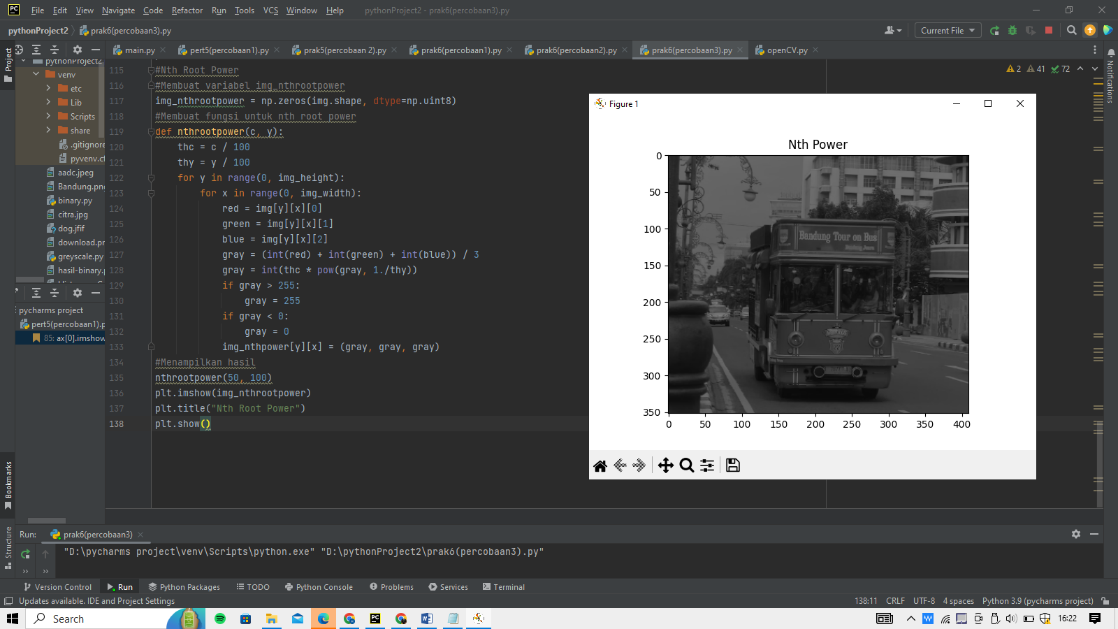

* NTH Root Power

